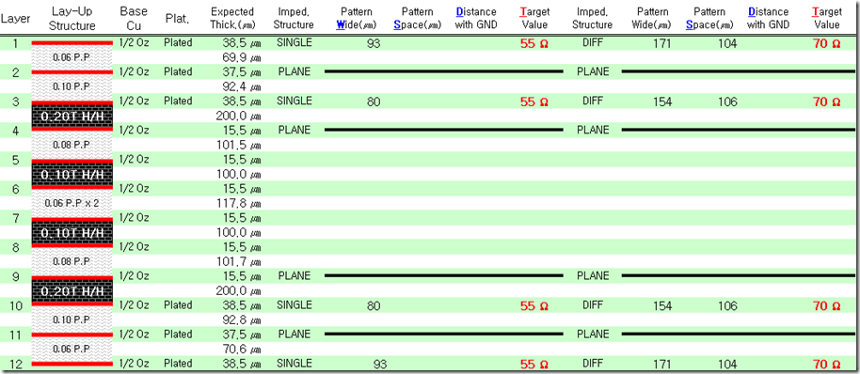

**http://www.iMX6Rex.com**

**iMX6 Rex Module Stackup**

